**Experiment 5:**

T Raja Aadhithan

602162021

**Write a Perl program to multiply two matrices.**

**Code:**

#!/usr/bin/perl

my @mat1=([0,0,0],[0,0,0],[0,0,0]);

my @mat2=([0,0,0],[0,0,0],[0,0,0]);

my @mat3=([0,0,0],[0,0,0],[0,0,0]);

print " values of matrix 1: \n";

print "enter 1,1 \t";

chomp($mat1[0][0] = <STDIN>);

print "enter 1,2 \t";

chomp($mat1[0][1] = <STDIN>);

print "enter 1,3 \t";

chomp($mat1[0][2] = <STDIN>);

print "enter 2,1 \t";

chomp($mat1[1][0] = <STDIN>);

print "enter 2,2 \t";

chomp($mat1[1][1] = <STDIN>);

print "enter 2,3 \t";

chomp($mat1[1][2] = <STDIN>);

print "enter 3,1 \t";

chomp($mat1[2][0] = <STDIN>);

print "enter 3,2 \t";

chomp($mat1[2][1] = <STDIN>);

print "enter 3,3 \t";

chomp($mat1[2][2] = <STDIN>);

print " \n Matrix 1: \n";;

for (my $i = 0; $i <= $#mat1; $i++){

    for (my $m = 0; $m <= $#mat1; $m++){

        print $mat1[$i][$m], "\t";

    }

    print "\n";

}

print "\n values of matrix 2: \n";

print "enter 1,1 \t";

chomp($mat2[0][0] = <STDIN>);

print "enter 1,2 \t";

chomp($mat2[0][1] = <STDIN>);

print "enter 1,3 \t";

chomp($mat2[0][2] = <STDIN>);

print "enter 2,1 \t";

chomp($mat2[1][0] = <STDIN>);

print "enter 2,2 \t";

chomp($mat2[1][1] = <STDIN>);

print "enter 2,3 \t";

chomp($mat2[1][2] = <STDIN>);

print "enter 3,1 \t";

chomp($mat2[2][0] = <STDIN>);

print "enter 3,2 \t";

chomp($mat2[2][1] = <STDIN>);

print "enter 3,3 \t";

chomp($mat2[2][2] = <STDIN>);

print "\n Matrix 2: \n";

for (my $i = 0; $i <= $#mat2; $i++){

    for (my $m = 0; $m <= $#mat2; $m++){

        print $mat2[$i][$m], "\t";

    }

    print "\n";

}

for (my $i = 0; $i <= $#mat1; $i++){

    for (my $m = 0; $m <= $#mat2; $m++){

        $a = $mat1[$i][1]*$mat2[1][$m];

        $b = $mat1[$i][2]*$mat2[2][$m];

        $c = $mat1[$i][0]*$mat2[0][$m];

        $mat3[$i][$m] = $a + $b + $c;

        chomp($mat3[$i][$m]);

    }

}

print "\n\n Output Matrix : \n";

for (my $i = 0; $i <= $#mat3; $i++){

    for (my $m = 0; $m <= $#mat3; $m++){

        print $mat3[$i][$m], "\t";

    }

    print "\n";

}

**Output:**

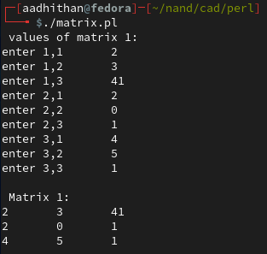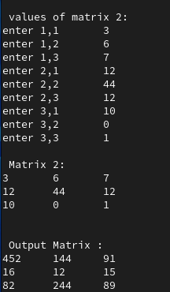

**Write a Perl program with UC(), LC() and length() functions.**

**Code:**

#!/usr/bin/perl

print "Enter string  \t";

$s = <STDIN>;

print("\nupper case : " ,uc($s));

print("lower case : " ,lc($s));

print("length of string :", length($s), "\n");

**Output:**

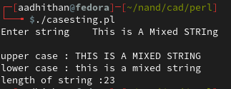

**Write a Perl program with split and join functions.**

**Code:**

#!/usr/bin/perl

print"Enter string 1 \t";

chomp($s1 = <STDIN>);

print"Enter string 2 \t";

chomp($s2 = <STDIN>);

print"Enter string 3 \t";

chomp($s3 = <STDIN>);

$string = join("-",$s1,$s2,$s3);

print("\n Joined String is : $string \n");

my @arr = split('-',$string);

print("\n Split String is : \n");

foreach my $i(@arr) { print "$i \n" };

**Output:**

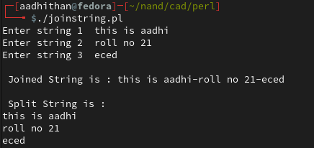

**Write a perl program to read all files of a text file.**

**Code:**

#!/usr/bin/perl

my $filename = '/home/aadhithan/nand/cad/perl/textfile.txt';

open(FH, '<', $filename) or die $!;

while(<FH>){

   print $_;

}

close(FH);

**Output:**

